
Overview

The Cisco Wireless Mesh Networking Solution for
Local Government

The Cisco Wireless Mesh Networking Solution plays an important role in enabling local governments and transportation agencies to enhance public safety and increase operational efficiency and service delivery.

CHALLENGE
EXECUTIVE SUMMARY
HARBORLINK NETWORK, LLC
● Dayton, Ohio, United States
INDUSTRY
● Professional Services/Technology
BUSINESS CHALLENGE
● Need to craft effective wireless solutions for public sector clients
● Need to ensure maximum security and reliability
● Need the flexibility to serve multiple constituents and support a wide range of applications
NETWORK SOLUTION
● Cisco Wireless Mesh Networking Solution
● Cisco Unified Wireless Network
BUSINESS RESULTS
● Reduces deployment and ongoing management costs
● Provides a robust, secure, solution
● Allows maximum flexibility for meeting requirements of any constituent

Local governments share common challenges: to maintain a safe environment for their citizens, increase service effectiveness, improve educational excellence, and drive economic development.
By adopting new business processes and
the technologies that make them possible, local governments are improving citizen safety, increasing the quality of their services, fostering educational excellence, and creating a business friendly environment.

To reach their goals, local government and transportation agencies face multiple operational challenges that are brought on from budget and staffing constraints, the desire to improve services to citizens, the mandate to improve collaboration and communication within and among agencies and
the continuing need to enhance public safety.

For example, first responders typically operate independently but are now mandated to communicate and share information with other government agencies. Improved collaboration and communication between agencies such as police and fire ensure the best possible outcome to emergency situations.

To fulfill this mandate, many agencies are opting to upgrade legacy systems such as Cellular Digital Packet Data (CDPD) and 800-MHz wireless technology with next-generation wireless networking equipment and applications. Legacy systems purchased years ago have low-bandwidth that prevents integration with newer, advanced applications such as video surveillance, traffic management control and other IP-based applications. In addition, the legacy network lacks frequencies, limiting the channel capacity for transmitting additional data.

With mounting pressure to increase revenues while reducing costs without sacrificing service delivery, local government officials are formulating strategies to:

● Enhance Public Safety—Using IT networks to integrate existing applications with new advanced applications, such as IP video surveillance and traffic monitoring systems.
● Improve Public Service Delivery—Increasing productivity and responsiveness of agency employees. This can be achieved by automating administrative tasks and by making information available to employees in the field, thereby reducing the need for trips back to headquarters.
● Improve Interagency Collaboration—Deploying network-oriented applications to improve information exchange between municipal, state, local, federal and transportation agencies.
● Improve Transportation Systems and Infrastructure—Upgrading existing public transit and roadways with the latest intelligent transportation system (ITS) to better manage internal operations and to proactively prevent incidents by monitoring traffic and public safety in potential trouble areas.
● Increase Economic Development—Forming city and community partnerships with neighborhood groups, schools, and small businesses to develop programs and create
opportunities to promote economic growth in the city.

EXECUTIVE SUMMARY
Local government and transportation agencies are often challenged to manage their operations more efficiently, improve services to citizens, and enhance public safety with limited resources.
Government agencies implement technology to meet these challenges but often times, the technology needed to improve operations is costly and complex to maintain. The Cisco Wireless Mesh Networking Solution offers innovative technologies such as zero-touch configuration, self-healing, self optimization, and dynamic route capabilities that simplify network deployment management and maintenance. This solution enables new applications to accelerate communications and services, while simplifying delivery of applications, lowering operational costs, and improving government effectiveness and responsiveness.

CISCO WIRELESS MESH NETWORKING SOLUTION OVERVIEW

Solution
With the Cisco® Wireless Mesh Networking Solution, local government, public safety, and transit agencies can extend their existing wired-network-oriented services and applications beyond their building walls and across the city. This provides innovative new ways to enable communications and service delivery to agency employees and citizens in the community.

The Cisco Wireless Mesh Network is a single, integrated, secure, and high-speed network which enables government agencies to rapidly deploy new applications such as video surveillance, traffic management and other IP-based applications. The mesh network is ideally suited for metropolitan networks, because it is easy to install on buildings and streetlight posts and is designed to scale to large outdoor deployments.
The Cisco Wireless Mesh Networking Solution is composed of products from the Cisco Unified Wireless Network architecture. It includes Cisco Aironet® 1500 Series lightweight outdoor mesh access points that can be deployed with zero-touch configuration. Intelligent wireless routing, based on the Adaptive Wireless Path Protocol (AWPP) creates a wireless mesh infrastructure that dynamically optimizes the network routes and self heals from interference or outages, while
the Radio Resource Management (RRM) software allows mesh access points to monitor their environments and adjust channels and frequencies in real time to avoid interference from other wireless devices. These automated capabilities help reduce deployment and maintenance costs.

The Cisco Aironet 1500 Series is connected to Cisco wireless LAN controllers and is managed by the Cisco Wireless Control System (WCS). The wireless LAN controller is responsible for system wide wireless LAN functions such as security policies, intrusion prevention, RF management, quality of service (QoS), and mobility. Cisco WCS centralizes wireless LAN systems management of RF prediction, policy provisioning, network optimization, troubleshooting, user tracking, and security monitoring.

The Cisco Wireless Mesh Networking Solution provides agencies and individuals with access to fixed and mobile applications to enhance public safety, efficiency, productivity, and responsiveness (see Figure 1).

Figure 1. Wireless Mesh Network

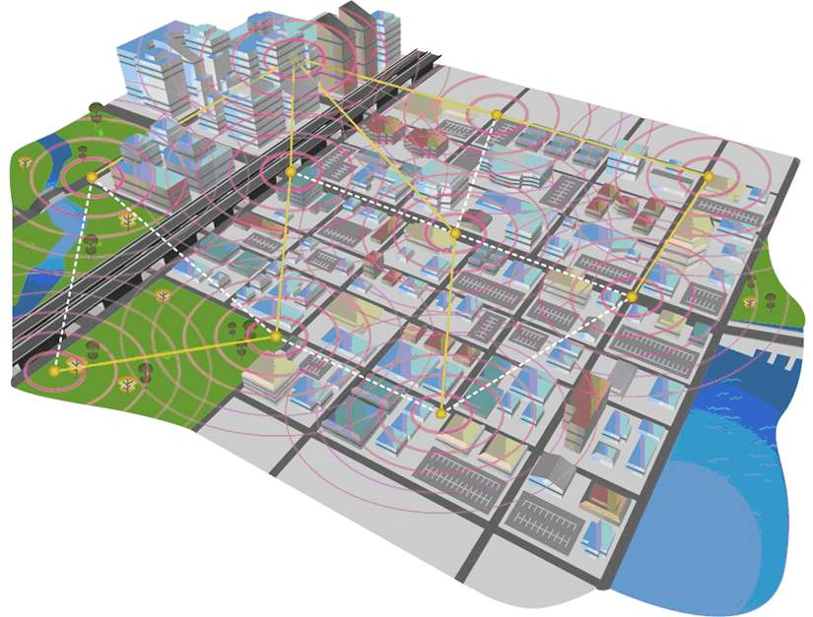

A properly designed and configured wireless network provides the necessary safeguards for data security and in-band radio interference. This is important for mobile users that require secure remote access over wireless LANs to connect back to their private data networks. Wireless technology enables flexible, mobile, and dynamic communications. It provides ease of deployment, the ability to deploy network devices where running fiber is cost-prohibitive, and the ability to
quickly and easily add networked devices.

HarborLink Network, LLC, a wireless LAN solution provider, uses the Cisco Wireless Mesh Networking Solution as the foundation for its mobile wireless network offering for the City of Dayton in Ohio.
In 2003, HarborLink approached the City of Dayton about deploying a pilot wireless solution in the heart of the city’s downtown. The one-square-mile deployment would serve as a proving ground for the city’s own wireless plans, as well as for HarborLink’s metro wireless business model. HarborLink chose the Cisco Wireless Mesh Networking Solution to support this critical showcase solution.
“We tested products from several different vendors, but most of the solutions just didn’t have the immediate capabilities we needed or the future capabilities we thought we would need if the project expanded,” says Rick Tangeman, president, HarborLink Network. “But when we looked at the technology from Cisco, the business model suddenly became feasible.”
In the City of Dayton, HarborLink deployed 18 Cisco Aironet 1500 Series wireless mesh access points and a Cisco 4400
Series wireless LAN controller. The wireless LAN controller allows HarborLink to provide all configuration and management functions for the access points from the centralized controller, which is managed remotely from HarborLink’s headquarters. Due to the centralized nature of the technology, individual wireless access points required no configuration during the installation, and will require none in the future, regardless of how the network changes. The solution also offers a rich feature set, including integrated Radio Resource Management (RRM) capabilities that allow access points to
monitor their environments and adjust channels and frequencies in real time to avoid interference from other wireless devices.
The Cisco Wireless Mesh Networking Solution also offered HarborLink maximum flexibility for the deployment. With support for a variety of RF frequencies, HarborLink could deploy the Dayton solution with intra-access point/controller communications in the 5-GHz frequency range, avoiding reliance on the more commonly used (and often problematic)
2.4-GHz frequency. And, the Cisco Wireless Mesh Networking Solution was the only wireless technology available to offer uninterrupted indoor/outdoor wireless roaming and management, laying the groundwork for future applications.

ARCHITECTURE

The Cisco Wireless Mesh Network architecture (Figure 2) is based primarily on the Cisco Aironet
1500 Series, which operates with Cisco wireless LAN controllers and Cisco WCS, centralizing key functions of wireless LANs to provide scalable management, security, and mobility between indoor and outdoor deployments. Designed to support zero-configuration deployments, the Cisco Aironet
1500 Series easily and securely joins the mesh network, and is managed and monitored by Cisco WCS. Compatible with Wi-Fi Protected Access 2 (WPA2) and employing hardware-based Advanced Encryption Standard (AES) encryption between wireless nodes, the Cisco Aironet 1500
Series provides end-to-end security.

Figure 2. Wireless Mesh Network Architecture

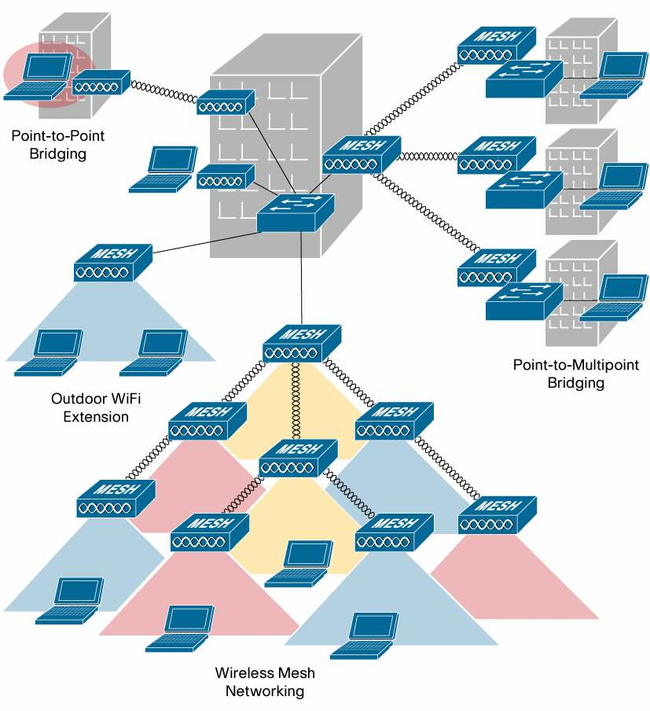

● Cisco Aironet 1500 Series Outdoor Wireless Mesh Access Point—With configurations for either single-radio support for IEEE 802.11 b/g or dual-radio simultaneous support for IEEE 802.11a and 802.11b/g standards, Cisco Aironet 1500 Series outdoor wireless mesh access points employ the Adaptive Wireless Path Protocol (AWPP) to form a dynamic wireless mesh network between remote access points, and deliver secure wireless access to any Wi-Fi-compliant client.
● Cisco Wireless LAN Controller—The Cisco Wireless LAN Controller supports an innovative architecture for large-scale wireless LANs by considering individual access
points as part of a larger system, and centralizing certain functions of the 802.11 protocol. It
uses the Lightweight Access Point Protocol (LWAPP) to communicate with the Cisco Aironet 1500 Series and deliver system-level management of device configuration, security policies, and RF parameters while providing Layer 2 or Layer 3 mobility.
● Cisco Wireless Control System—Cisco WCS provides a powerful foundation that allows IT managers to design, control, and monitor outdoor wireless networks from a centralized location, simplifying operations and reducing total cost of ownership.

The following solutions, used by different agencies, are based on the Cisco Wireless Mesh
Networking Solution.

Public Safety Solution
Police, fire, and emergency medical services agencies are using wireless technologies to enhance safety throughout the community by improving the management of resources and the quality and flow of information. Some of the applications supported are:

● IP Video Surveillance—Allows agencies to better manage and monitor many locations throughout a city. With IP surveillance cameras installed on lamp-posts, buildings, and in patrol cars, police can use their PDAs and laptops to wirelessly tap into any camera that is integrated into the network. This allows the police to quickly gain access to time sensitive information on mission-critical situations and provide immediate responses in a timely manner.
● Community Policing—Allows for secure broadband access to databases, fingerprints, and photo images from anywhere in the community. Secure, high-speed capabilities are necessary to upload and download field reports and images that require fast data throughput.
● Communications Interoperability—Provides a unified IP network infrastructure that allows multiple agencies to communicate and collaborate with each other, thereby
improving the flow of information and ability for first responders to respond to an emergency
situation.

● Telemedicine—Allows doctors and emergency room technicians to diagnose and monitor patient conditions as they travel on the road to the hospital. With access points deployed along streets and roadways, ambulances can be equipped with mobile networks and video cameras to provide two-way video image and voice communications between
the ambulance and emergency medical centers. This type of application is critical to improving the safety and health of citizens in the community.

Field Service Worker Solution
Local government agencies are deploying the Cisco Wireless Mesh Networking Solution to improve business operations efficiency and to provide better service delivery to citizens. Having access to the government database in the field saves time in retrieving business-critical data, allowing employees to be more productive and improve services to the community.

Applications supported include:

● Ubiquitous Wireless Access—The ability to connect from anywhere in the community to the government database is critical for agency employees. This saves time and effort, improving employee productivity and service delivery response. Government employees such as building inspectors would be more productive in enforcing licensing and building permits in the field with easy access to government database from anywhere in
the community.

● Data Collection—Many services performed by government employees across
the community involve collecting data and filing reports. City inspectors, public works crews, utility crews, social workers, and other government employees can now carry laptops, PDAs, and other wireless handheld devices to capture data. This improves the

accuracy of information captured at an onsite location, and reports that are immediately filed and sent to department headquarters helps to avoid delays in service delivery.
● Information Data Sharing—A standards-based IP network foundation provides a common infrastructure, integrating intelligent information network services and applications. This allows multiple agencies to have access to and share the same business-critical
information for better decision-making.

Public Transit Solution
Public transit agencies are deploying ITS to better manage resources, improve security, and streamline their operations. The Cisco Wireless Mesh Networking Solution provides a network infrastructure that enables ITS applications to be deployed, which in turn allows transit agencies to access real-time information, manage operational resources, enhance security, and improve service delivery to their passengers.

Applications supported include:

● Intelligent Stations—Enables integrated communications so that voice, video, and data can be more easily shared and services can be more easily performed for all stations, terminal operations, and passenger information services. A wireless network can be deployed to support ticketing and fare collection, information kiosks, video surveillance, and public wireless LAN service.
● Intelligent Track Side—Provides an intelligent corridor along the track side, allowing trains to have constant high-speed connectivity along the track to support applications enabled on both the vehicles and along the railroad. The Cisco Wireless Mesh Networking Solution can be deployed to support applications like video surveillance, computer-based train control systems, and integrated communications systems along the track.

Business Benefits
With the deployment of a Cisco Wireless Mesh Networking Solution, local government agencies will be able to use their existing wired network infrastructures, extending their resources and applications capabilities to the wireless network, and out to mobile users. The standards-based network allows agencies to enable new applications, integrate existing applications, and add new, advanced applications to deliver services to citizens. This solution allows local governments to
cost-effectively manage their resources, and improve operational efficiencies and responsiveness. Additional benefits include:

● Secure Remote Access—Allows mobile users to have broadband, secure access to confidential business data in the field, helping to increase productivity.
● Mobility—Provides smooth roaming between outdoor locations in the city, allowing mobile users to access applications.
● Scalability—Provides the capability and flexibility to add additional nodes at any time, to any location. Network resources can be extended, and the network can grow to more locations community-wide, as demand requires.
● Manageability—Provides easy deployment and centralized management capability for both wired and wireless IP network infrastructures, reducing the cost of managing the citywide network.
● Applications Interoperability—Allows existing applications to interoperate and integrate with new, open-standards-based applications for improved service delivery.

● Return on Investment and Investment Protection—Allows deployment with a lower total cost of ownership and provides a migration path for future technology upgrades.

Why Cisco
Many vendors offer point product solutions that only address a portion of a customer’s requirements and deliver a partial solution that is not integrated with the core network. The Cisco Wireless Mesh Network is built on a standards-based Service-Oriented Network foundation that offers a unique, innovative architecture allowing the network to enable next-generation applications, business processes, and profitability. This network delivers a unified, consistent set of network features that allow customers to use the existing Cisco solutions invested in the wired network and to extend intelligent network features and capabilities out to mobile users across the city. Due to a tighter integration of applications with the standards-based IP network, end to end Cisco solutions help to ensure a positive user experience and a consistent level of performance.

Cisco offers:

● Unique qualifications to extend IP networks to outdoor environments, integrating wired and wireless networks
● Standards- and IP-based (nonproprietary) solutions, allowing for interoperability and integration with existing and new applications
● An end-to-end solution with wired and wireless integration for a low total cost of ownership

● A set of solutions that encompass numerous deployment scenarios with diverse requirements, including innovations in the areas of scalability, mobility, security, and management, as well as convergence between 802.11 and cellular technologies
● Investment protection that allows for migration to future technology

● Industry-leading service and technical support through certified systems integration and channel partners, or from the Cisco Advanced Services team and Cisco SMARTnet® Onsite service programs
For more information about the Cisco Wireless Mesh Networking Solution, contact your local account representative or visit: http://www.cisco.com/go/wirelessmesh

For more information about the Cisco Unified Wireless Network, visit:
http://www.cisco.com/go/unifiedwireless

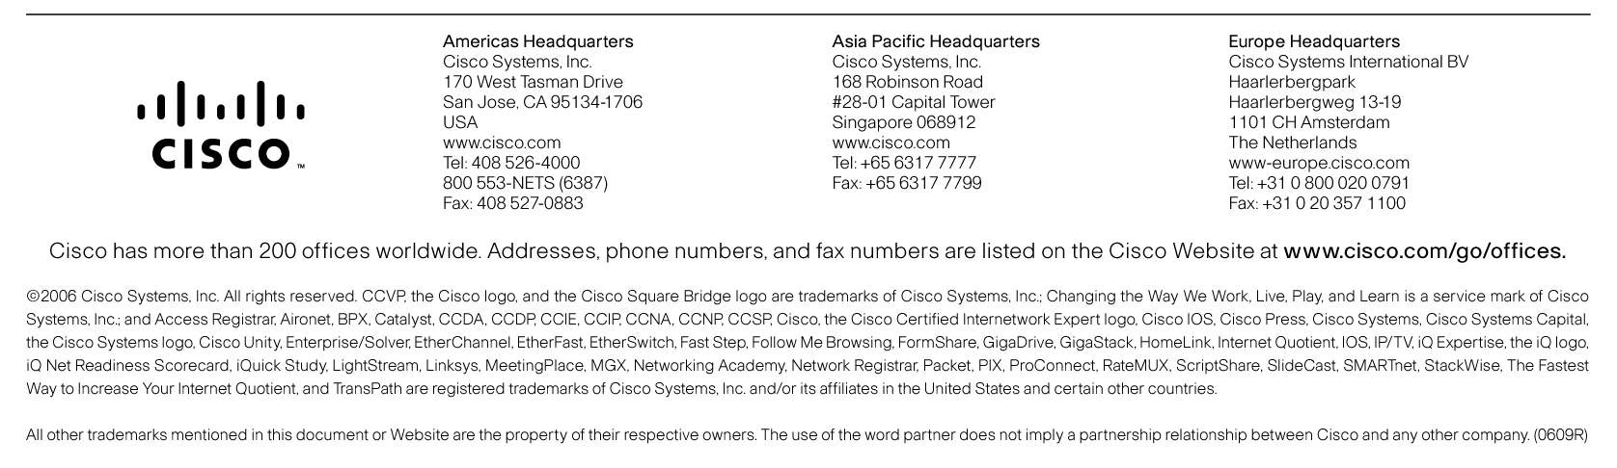

Printed in USA C22-377860-00 10/06

